H.T No
Regulations:
A18

Sreenidhi Institute of Science and Technology
(An Autonomous Institution)
Code No: 7AC02 Date: 30-Jan-2025 (FN)
B.Tech I-Year I- Semester External Examination, January-2025 (Supplementary)
NETWORK ANALYSIS (ECE)

Time: 3 Hours Max.Marks:70

Note: a) No additional answer sheets will be provided.
b) All sub-parts of a question must be answered at one place only, otherwise it will not be valued.
c) Missing data can be assumed suitably.
Bloom's Cognitive Levels of Learning (BCLL)

Remember | L1 | Apply | L3 | Evaluate | L5
Understand | L2 | Analyze | L4 | Create | L6

Part - A Max.Marks:20

Answer all QUESTIONS.

 |  | BCLL | CO(s) | Marks
1 | Compare series and parallel connection. | L2 | CO1 | [2M]
2 | Define graph and incidence matrix. | L2 | CO2 | [2M]
3 | Define fringing. | L1 | CO3 | [2M]
4 | What is meant by complex power? | L2 | CO4 | [2M]
5 | What is bandwidth and selectivity? | L2 | CO5 | [2M]
6 | What are the limitations of maximum power transfer theorem? | L1 | CO6 | [2M]
7 | What is difference between loop and mesh? | L1 | CO1 | [2M]
8 | What are the advantages of sinusoids? | L2 | CO4 | [2M]
9 | State Millmann’s Theorem. | L1 | CO6 | [2M]
10 | State the dot rule for coupled circuits. | L2 | CO3 | [2M]

Part – B Max.Marks:50
ANSWER ANY FIVE QUESTIONS. EACH QUESTION CARRIES 10 MARKS.

 |  |  | BCLL | CO(s) | Marks
11. |  | Find the voltage across the dependent current source (v_{y}) in the circuit shown in fig  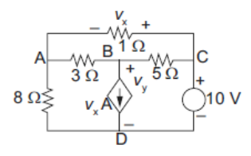 | L3 | CO1 | [10M]
12. |  | Find the node voltages in the circuit. Prepare the network graph with the reference direction for currents as marked in the fig.  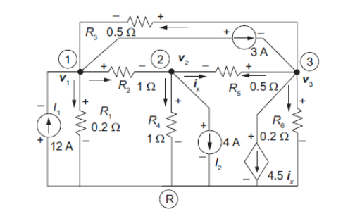 | L3 | CO2 | [10M]
13. | a) | Two coils connected in series have an equivalent inductance of 0.8 H when connected in aiding, and an equivalent inductance of 0.5H when connected in opposing. Calculate the mutual inductance of the coils. | L3 | CO3 | [5M]
 | b) | Write the mesh equations for the network shown in fig.  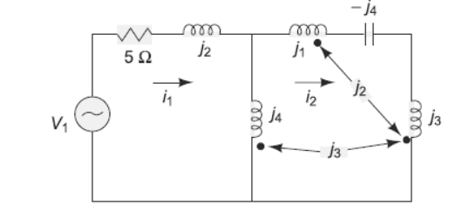 | L3 | CO3 | [5M]
14. |  | Explain the rms value and average value of alternating quantity. Derive its necessary expressions. | L2 | CO4 | [10M]
15. |  | A series RLC circuit has a quality factor of 10 at 200 rad/sec. The current flowing through the circuit at resonance is 0.5 A and the supply voltage is 10 V. The total impedance of the circuit is 40Ω. Find the circuit constants. | L3 | CO5 | [10M]
16. |  | Find voltage across the 10Ω and power dissipated in all resistors by using superposition principle in the circuit shown.  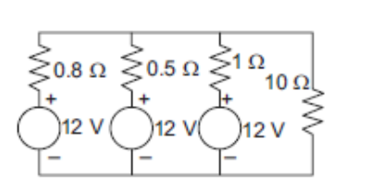 | L3 | CO6 | [10M]
17. | a) | Explain the concept of supernode and supermesh | L2 | CO1 | [4M]
 | b) | Draw the graph represented by the matrix A  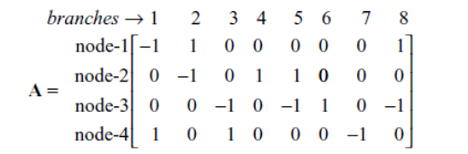 | L3 | CO2 | [3M]
 | c) | Two inductively coupled coils have self-inductance L₁ = 50 mH and L₂ = 200 mH, if the coefficient of coupling is 0.5, compute the value of mutual inductance between the coils. | L3 | CO3 | [3M]
18. | a) | For the parallel circuit shown in fig, find the currents and the total current and construct the phasor diagram.  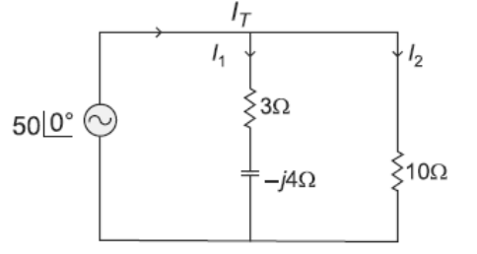 | L3 | CO4 | [4M]
 | b) | Derive the expression for Bandwidth of a series RLC circuit. | L4 | CO5 | [3M]
 | c) | Determine the maximum power delivered to the load in the circuit shown in fig  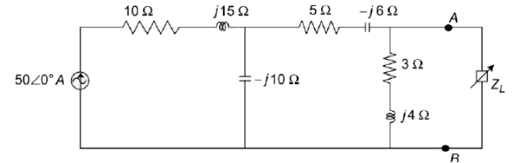 | L3 | CO6 | [3M]
-- 00 -- 00 –

